Experiment-8

Create a Virtual Hard Disk and allocate the storage using VM ware Workstation

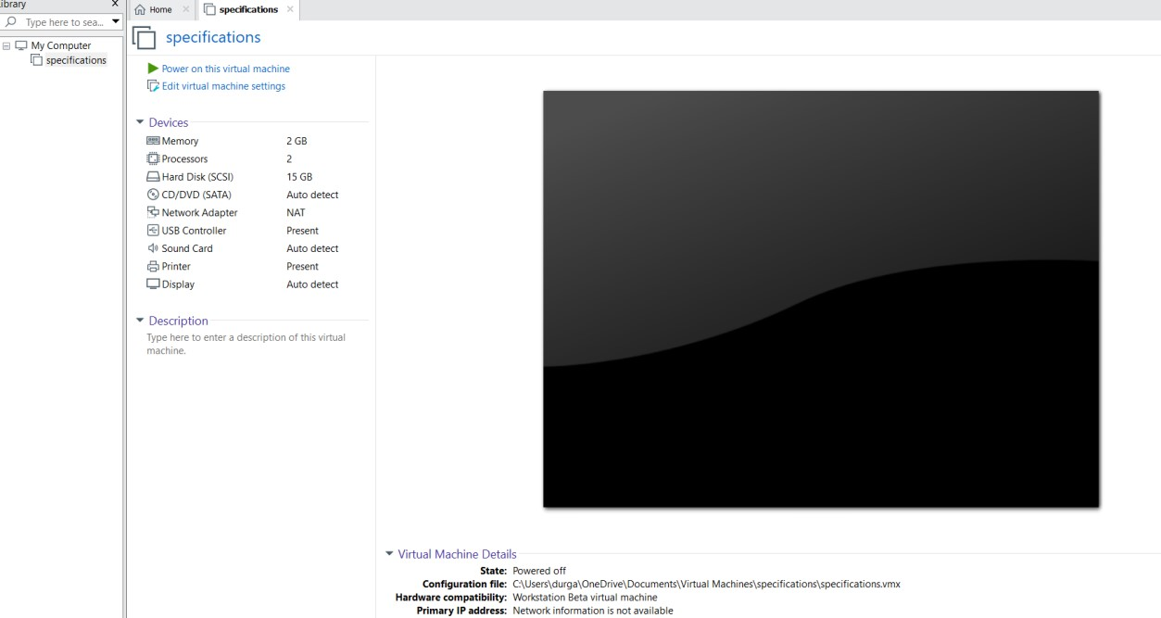

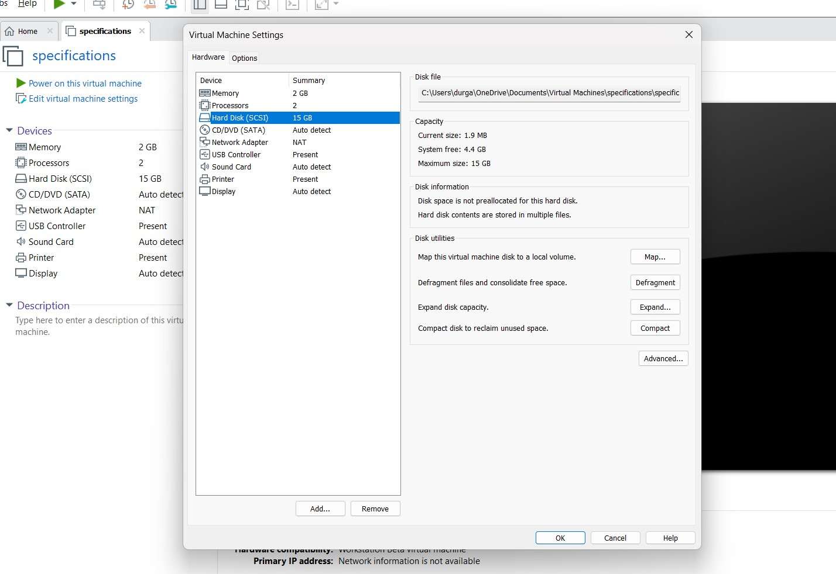

1. Vamsi K {192210355}

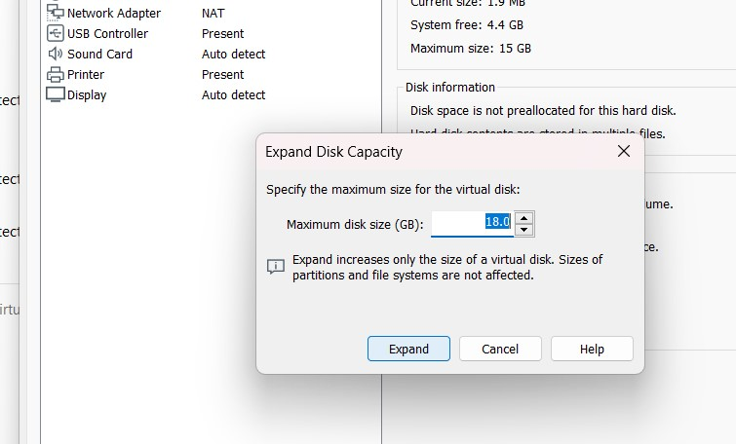

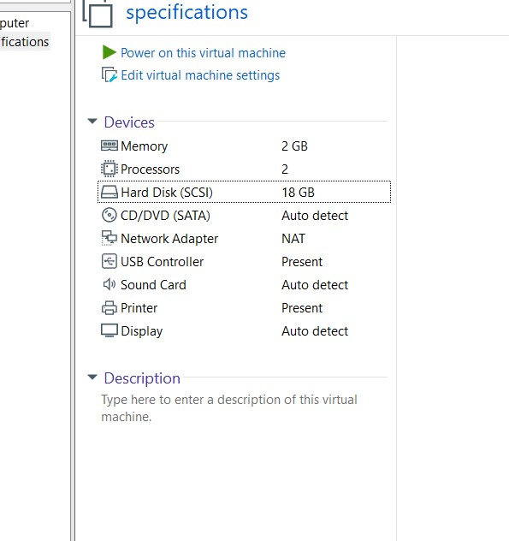

1. Vamsi K {192210355}